VNU-HCM International University



TRAIN TICKET MANAGEMENT
Final Project Report

Subject: Web Application Development
Instructor: Nguyen Trung Nghia
Group Members:
Le Nhat Duy - ITITWE22143
Nguyen Dinh Minh Quan – ITITWE22178
December 2025

Contents
I. Introduction ........................................................................ 1
1.1 Project Overview .................................................................. 1
1.2 Objectives ........................................................................... 1
1.3 Scope .................................................................................. 1
1.4 Technologies Used .............................................................. 1
II. Requirement Analysis .......................................................... 2
2.1 Actors .................................................................................. 2
2.2 Use Cases & Functional Requirements .................................. 2
2.2.1 UC01 – Search Train (Enquiry) ........................................ 2
2.2.2 UC02 – View Search Result .............................................. 2
2.2.3 UC03 – Booking (Create Reservation) .............................. 3
2.2.4 UC04 – Add Passenger Details .......................................... 3
2.2.5 UC05 – Payment (QR / COD / Card) .................................. 3
2.2.6 UC06 – My Tickets ............................................................ 3
2.2.7 UC07 – Cancel Ticket ........................................................ 4
2.3 Non-Functional Requirements .............................................. 4
III. System Design .................................................................... 5
3.1 System Architecture (Simple 3-tier) ..................................... 5
3.2 Database Design (ERD Description) ...................................... 5
3.3 Trigger Design for Ticket Cancellation .................................. 6
IV. Implementation .................................................................... 7
4.1 Main Functional Flow ............................................................ 7
4.2 Payment Module (QR) ............................................................ 7
4.3 My Tickets – Display Payment Status .................................... 8
V. Testing .................................................................................. 9
5.1 Sample Test Cases .................................................................. 9
5.2 Issues Encountered & Fixes .................................................... 9
VI. Discussion & Conclusion .................................................... 10
6.1 Achievements ...................................................................... 10
6.2 Limitations .......................................................................... 10
6.3 Future Enhancements ........................................................... 10
VII. References ........................................................................ 11

I. Introduction
1. Project Overview
The Railway Reservation System is a web application that allows users to search for trains, book tickets, enter passenger information, choose a payment method (QR/COD/Card), and view booked tickets. The system uses a MySQL database to store information about stations, train schedules, seat classes, available seats, reservations (PNR), passenger details, and payment status.
2. Objectives
- Provide a complete booking flow from Station A → Station B by selected date.
- Manage remaining seats based on seat class and route.
- Generate a unique PNR for each reservation.
- Integrate a basic payment flow:
  - QR payment is shown using the internal project image qr.png (not an external URL).
  - Save payment records into the payments table.
  - Allow users to view tickets (My Tickets) and display Payment Status.
- Support ticket cancellation and automatically restore seats / compute refunds using database triggers.
3. Scope
- User side: Search → Booking → Passenger Details → Payment → My Tickets → Cancel Ticket
- Admin side (if implemented): Manage train/station/schedule/classseats data
4. Technologies Used
- Frontend: HTML/CSS, Bootstrap 5, Font Awesome, lightweight JavaScript
- Backend: PHP (session-based), MySQLi
- Database: MySQL (Triggers for cancellation logic)
- Local environment: XAMPP / phpMyAdmin

II. Requirement Analysis
1. Actors
- Registered User: Book tickets, view tickets, cancel tickets, and track payment status.
- Admin: Manage master data (train, station, schedule, class seats).
2. Use Cases & Functional Requirements
UC01 – Search Train (Enquiry)
User story: As a user, I want to select departure station, destination station, and journey date to search for available trains.
Functional Requirements:
- Display station list (from station table).
- User selects sp, dp, doj.
- Return matching train results with departure/arrival time, class, fare, and remaining seats.
UC02 – View Search Result
Functional Requirements:
- Show result table: Train No, Name, Departure, Arrival, Class, Fare, Seats Left.
- Allow user to choose Train + Class and number of seats to book.
UC03 – Booking (Create Reservation)
Functional Requirements:
- Validate booking rules (e.g., at least one adult ≥ 18).
- Create a reservation record in resv (PNR auto-generated).
- Decrease seatsleft in classseats.
UC04 – Add Passenger Details
Functional Requirements:
- Input passenger list based on nos.
- Save to pd(pnr, pname, page, pgender).
UC05 – Payment (QR / COD / Card)
Functional Requirements:
- User selects payment method.
- If QR, display internal image qr.png from the project folder.
- Save payment record into payments (pnr, method, status=PENDING/PAID, txn_ref, …).
UC06 – My Tickets
Functional Requirements:
- User logs in using mobile and password.
- Display bookings from resv.
- Display payment status using a JOIN to payments.
UC07 – Cancel Ticket
Functional Requirements:
- User enters PNR to cancel (must belong to the logged-in user).
- Update resv.status = 'CANCELLED'.
- Trigger automatically handles:
  - Block cancellation if journey date has passed.
  - Restore seats to classseats.
  - Insert refund record to canc(pnr, rfare) based on refund rules.
3. Non-Functional Requirements
- Security: Use prepared statements for sensitive operations (e.g., login) to prevent SQL injection.
- Reliability: Reservation and payment data must remain consistent; triggers enforce cancellation rules automatically.
- Usability: Clear, responsive UI using Bootstrap and user-friendly error messages.
- Maintainability: Separate PHP files by feature (enquiry, result, booking, payment, tickets, cancel).

III. System Design
1. System Architecture (Simple 3-tier)
- Presentation layer: HTML/CSS/Bootstrap pages (index.htm, enquiry.php, enquiry_result.php, …)
- Application layer: PHP logic (session handling + booking/payment/cancel flows)
- Data layer: MySQL database (tables + triggers)
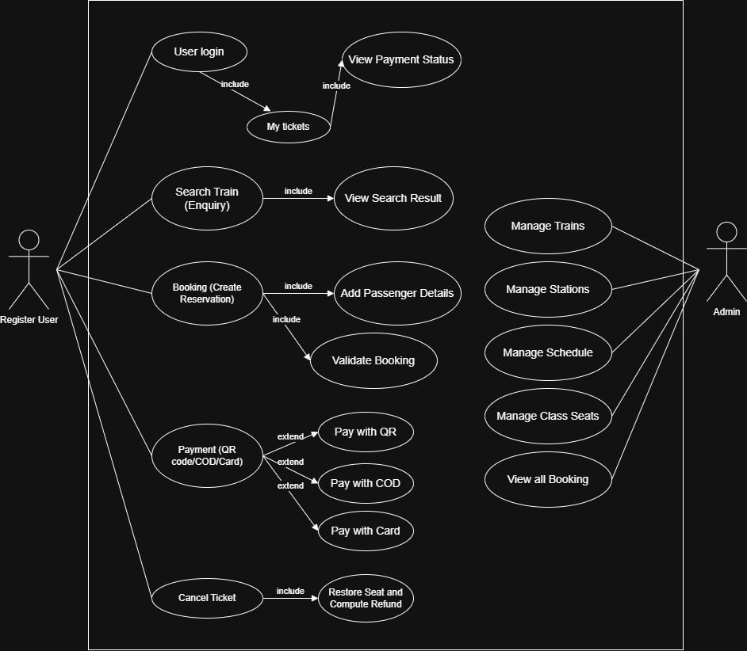
2. Database Design (ERD Description)
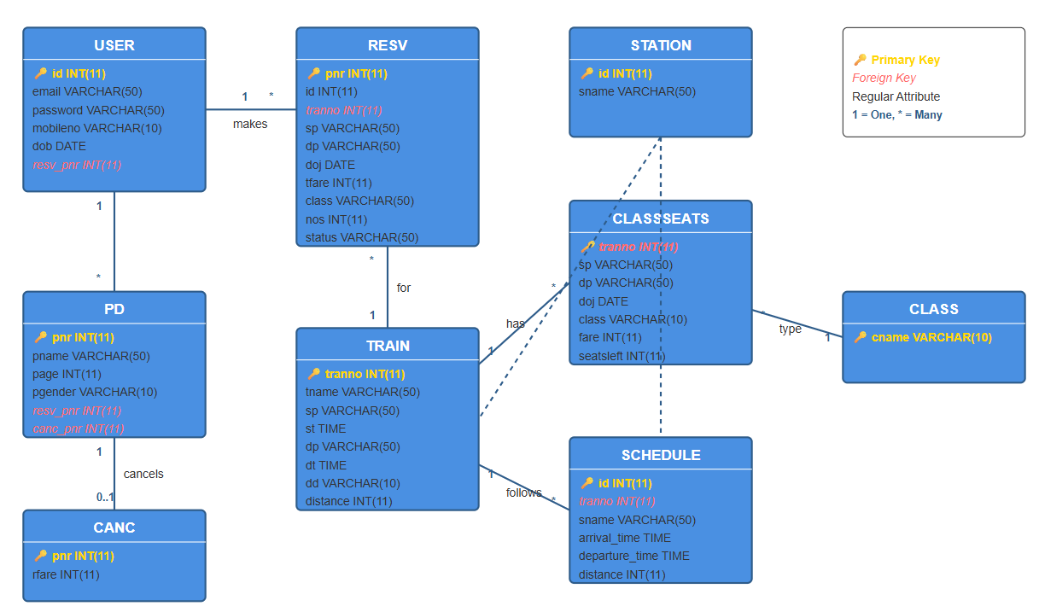
Main Tables:
- user(id, emailid, password, mobileno, dob, resv_pnr)
- station(id, sname)
- train(tranno, tname, sp, dp, st, dt, dd, distance)
- schedule(id, tranno, sname, arrival_time, departure_time, distance, tran_tranno)
- classseats(tranno, sp, dp, doj, class, fare, seatsleft)
- class(cname)
- resv(pnr, id, tranno, sp, dp, doj, tfare, class, nos, status)
- pd(pnr, pname, page, pgender, resv_pnr, canc_pnr, resv_pnr1)
- canc(pnr, rfare)
Key Relationships:
- user (1) → (n) resv - One user can make many reservations
- resv (n) → (1) train - Many reservations for one train
- resv (1) → (n) pd - One reservation has many passenger details
- resv (1) → (0..1) canc - One reservation may have one cancellation record
- train (1) → (n) classseats - One train has multiple class seat configurations
- train (1) → (n) schedule - One train follows multiple scheduled stops
- classseats (n) → (1) class - Many seat records belong to one class type
- station is referenced by train (sp, dp), schedule (sname), and classseats (sp, dp)
Important fix (to avoid Duplicate Entry error):
If canc.pnr is a PRIMARY KEY, repeated insert will cause error. Replace insert with UPSERT:
- INSERT ... ON DUPLICATE KEY UPDATE ...
(or delete old record before inserting, but UPSERT is cleaner).

IV. Implementation
1. Main Functional Flow
- index.htm → Book Ticket
- enquiry.php → choose From/To/Date → submit
- enquiry_result.php → show trains + booking form
- resvn.php → passenger details + payment method
- new_png.php → insert reservation + passengers + payment record
- user_login.php → My Tickets + payment status
- cancel.php → set status CANCELLED → trigger updates seats + refund
2. Payment Module (QR)
When user selects QR:
- UI displays <img src="qr.png"> using the internal image in the project directory.
When booking is created:
- Insert into payments: method='QR', status='PENDING', optional txn_ref, created_at.
A separate payment_confirm.php (optional) can later update PENDING → PAID.
3. My Tickets – Display Payment Status
Example query:
SELECT r.*, p.status AS pay_status, p.method AS pay_method
FROM resv r
LEFT JOIN payments p ON p.pnr = r.pnr
WHERE r.id = ?
ORDER BY r.pnr DESC;
UI suggestion:
- Ticket status badge: BOOKED / CANCELLED
- Payment badge: PAID (green), PENDING/UNPAID (yellow/red), NULL → UNPAID

V. Testing
1. Sample Test Cases
- TC01 Search valid trains: sp, dp, doj → returns train list.
- TC02 Booking all children: all ages < 18 → reject with “must have 1 adult”.
- TC03 Booking with QR: show qr.png; create records in resv, pd, payments(PENDING).
- TC04 My Tickets: login → list bookings + show pay_status.
- TC05 Cancel before journey date: restore seats + create refund record in canc.
- TC06 Cancel after journey date: trigger blocks cancellation.
2. Issues Encountered & Fixes
- Duplicate entry (PRIMARY/UNIQUE) when trigger inserts into canc more than once or when unique constraints conflict.
→ Fixed by using ON DUPLICATE KEY UPDATE or adjusting constraints based on business rules.

VI. Discussion & Conclusion
1. Achievements
- Implemented an end-to-end booking flow: enquiry → booking → passenger → payment → tickets → cancel.
- Improved UI with Bootstrap and clean layout.
- QR payment meets requirement: uses internal qr.png (not external URL).
- My Tickets shows payment status per PNR.
- Trigger ensures consistent seat restoration and refund rules.
2. Limitations
- Payment is simulated (no real payment gateway integration).
- Session-based flow depends on correct navigation order.
- Admin and user roles may not be fully separated if not implemented.
3. Future Enhancements
- Add “Confirm Payment” to update PENDING → PAID and store paid timestamp.
- Restrict viewing ticket details if payment is not PAID (optional).
- Improve security: hash passwords, stricter validation, CSRF protection.

VII. References
- PHP Manual – MySQLi Prepared Statements
- MySQL Documentation – Triggers and Constraints
- Bootstrap 5 Documentation
- Font Awesome Documentation

